

**20 级同等学力人员**

**申请临床医学硕士专业学位报名相关资料**

姓 名：

申请专业：

所属学院：

**武汉科技大学同等学力人员申请医学硕士专业学位报名表**

|  |  |  |  |  |  |  |  |  |  |  |  |  |  |  |  |  |
| --- | --- | --- | --- | --- | --- | --- | --- | --- | --- | --- | --- | --- | --- | --- | --- | --- |
| 姓名 |  | | | | | | 性别 | | |  | | | | | | |
| 民族 |  | | | | | | 政治面貌 | | |  | | | | | | |
| 身份证件类型 | | |  | | | | 证件号码 | | |  | | | | | | |
| 工作单位所在省市 | | |  | | | | 参加工作年月 | | |  | | | | | | |
| 工作单位 | | |  | | | | | | | | | 工作单位性质 | | | |  |
| 职称级别 | | |  | | | 职务级别 | | |  | | | 申请人类型 | | | |  |
| 移动电话 | | |  | | | 工作电话 | | |  | | | 非工作电话 | | | |  |
| 通信地址 | | |  | | | | | | | | | 邮政编码 | | | |  |
| 个 人 简 历 | 起止年月 | | 在何地、何部门、任何职务(从中学开始填写) | | | | | | | | | | | | | |
|  | |  | | | | | | | | | | | | | |
|  | |  | | | | | | | | | | | | | |
|  | |  | | | | | | | | | | | | | |
|  | |  | | | | | | | | | | | | | |
|  | |  | | | | | | | | | | | | | |
|  | |  | | | | | | | | | | | | | |
| 获前置学位专业 | |  | | 获前置学位年月 | | | |  | 学位授予单位 | | | | |  | | |
| 学位证书编号 | |  | | | | | | 拟申请硕士学位专业 | | | | |  | | | |
| 规培专业 | |  | | | 规培开始年月 | | |  | | | 规培结束年月 | | | |  | |
| 规培状态 | |  | | | 所在规培基地名称 | | |  | | | 规培证书编号 | | | |  | |

**2.居民身份证正反面**

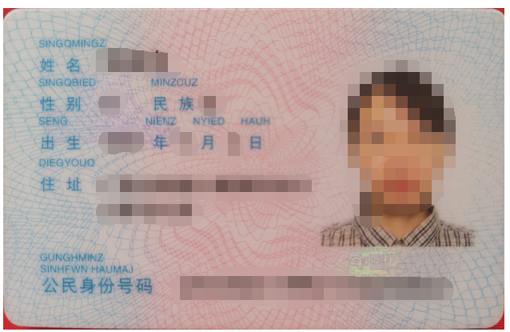

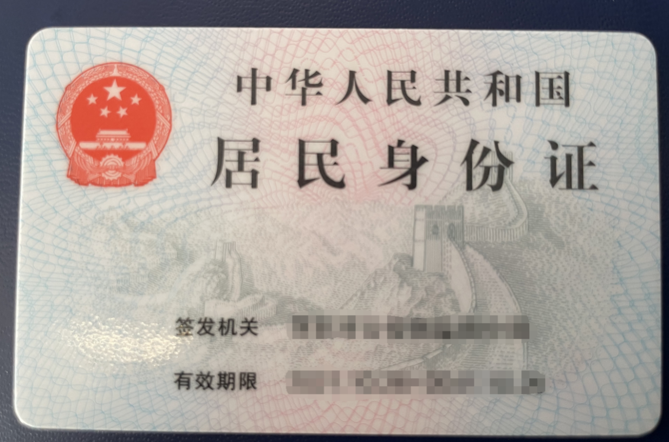

**3.毕业证书**

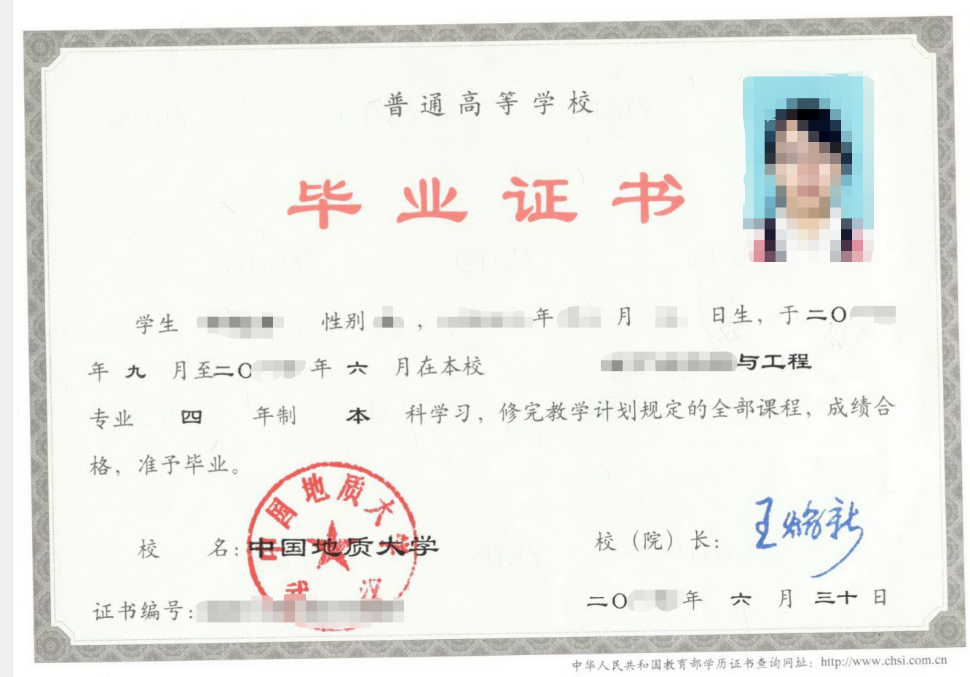

**4.学位证书**

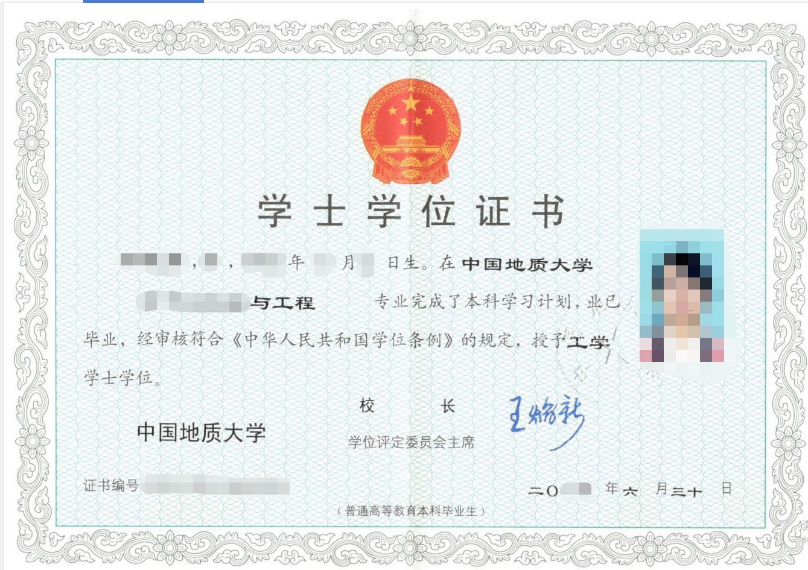

**5学位认证报告（或学位查询结果）**

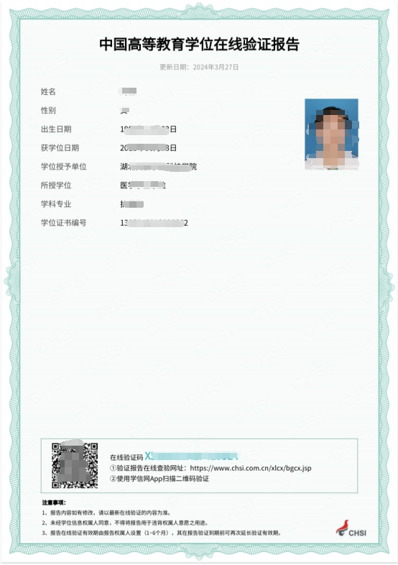

**6学历认证报告**

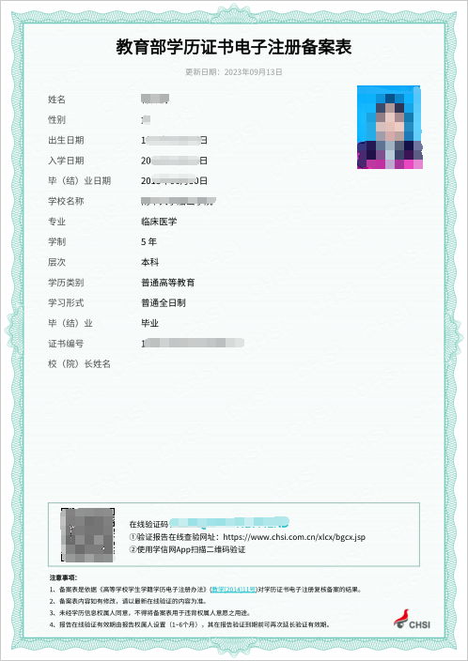

**7《住院医师规范化培训合格证书》或《住院医师规范化培训基地培训证明》**